EXERCISE NO 1 CREATION OF BASE TABLE AND

Date: DML OPERATIONS

Create table statement:

Insert values:

1. Create MY_EMPLOYEE table with the following structure?

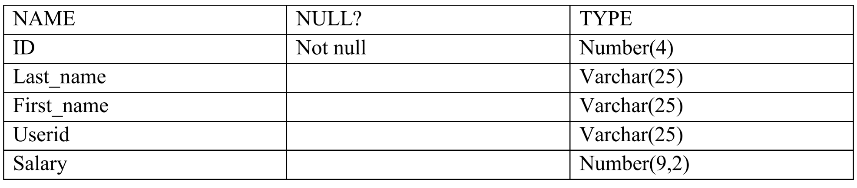

PROGRAM:

**CREATE TABLE MY_EMPLOYEE(ID NUMBER(4) NOT NULL,LAST_NAME VARCHAR2(25),FIRST_NAME VARCHAR2(25),USERID VARCHAR2(25),SALARY NUMBER(9,2));**

2. Add the first and second rows data to MY_EMPLOYEE table from the following sample

Data.

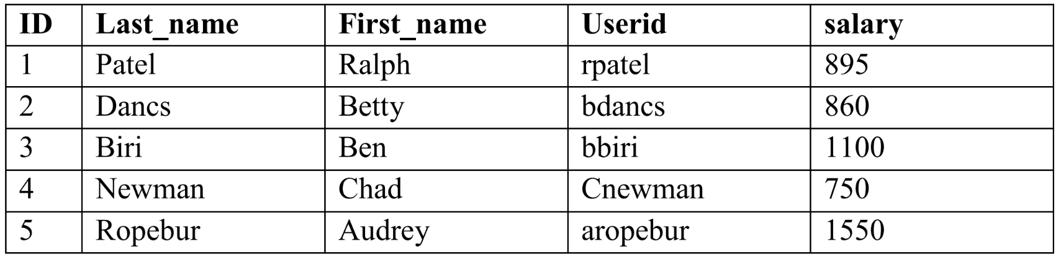

PROGRAM:

**BEGIN**

**INSERT INTO MY_EMPLOYEE VALUES (1, 'Patel', 'Ralph', 'rpatel', 895);**

**INSERT INTO MY_EMPLOYEE VALUES (2, 'Dancs', 'Betty', 'bdancs', 860);**

**END**

**/;**

3. Display the table with values.

PROGRAM:

**SELECT * FROM MY_EMPLOYEE;**



4. Populate the next two rows of data from the sample data. Concatenate the first letter of

the first_name with the first seven characters of the last_name to produce Userid.

PROGRAM:

**BEGIN**

**INSERT INTO MY_EMPLOYEE VALUES (3, 'Biri', 'Ben', 'bbiri', 1100);**

**INSERT INTO MY_EMPLOYEE VALUES (4, 'Newman', 'Chad', 'cnewman', 750);**

**END**

**/;**

CHECK:

**SELECT * FROM MY_EMPLOYEE;**

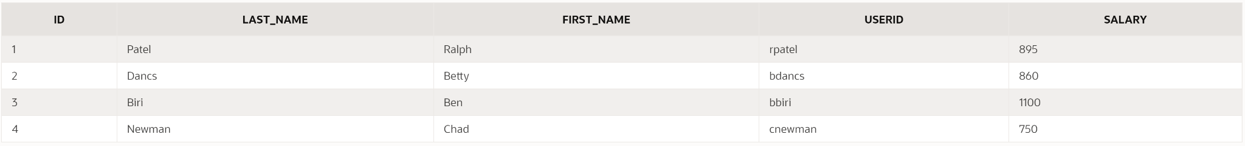

5. Delete Betty dancs from MY _EMPLOYEE table.

PROGRAM:

**DELETE FROM MY_EMPLOYEE WHERE LAST_NAME = 'Dancs' AND FIRST_NAME = 'Betty';**

CHECK:

**SELECT * FROM MY_EMPLOYEE;**



6. Empty the fourth row of the emp table.

PROGRAM:

**UPDATE MY_EMPLOYEE SET LAST_NAME = NULL, FIRST_NAME = NULL, USERID = NULL, SALARY = NULL WHERE ID = 4;**

CHECK:

**SELECT * FROM MY_EMPLOYEE;**



7. Make the data additions permanent.

PROGRAM:

**COMMIT;**

8. Change the last name of employee 3 to Drexler.

PROGRAM:

**UPDATE MY_EMPLOYEE SET LAST_NAME = 'Drexler'WHERE ID = 3;**

CHECK:

**SELECT * FROM MY_EMPLOYEE;**



9. Change the salary to 1000 for all the employees with a salary less than 900.

PROGRAM:

**UPDATE MY_EMPLOYEE SET SALARY = 1000 WHERE SALARY < 900;**

CHECK:

**SELECT * FROM MY_EMPLOYEE;**

